# docker run -p 80:80 devopsdockeruh/ports_exercise

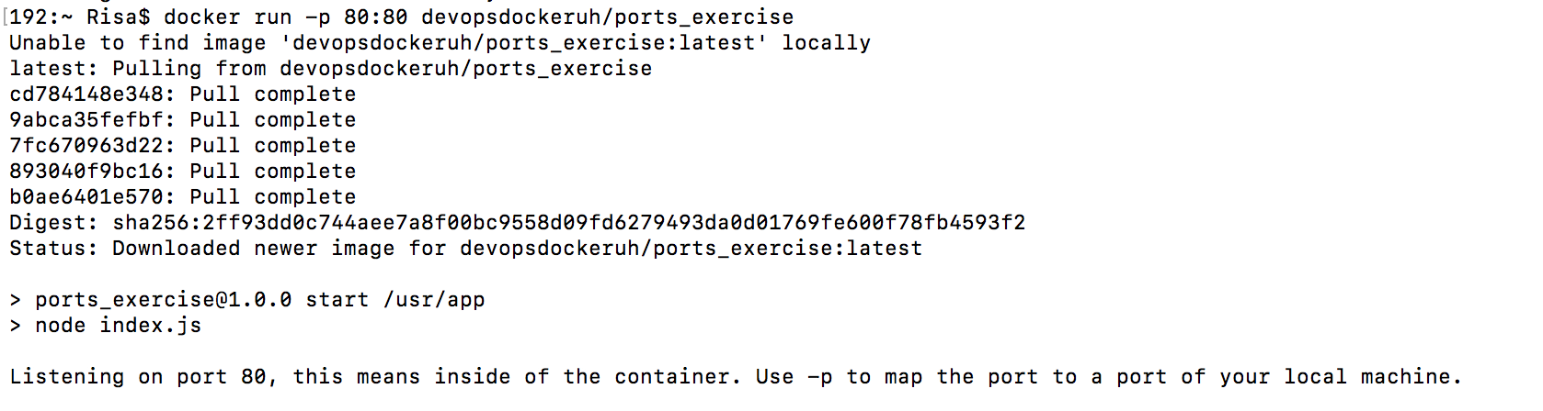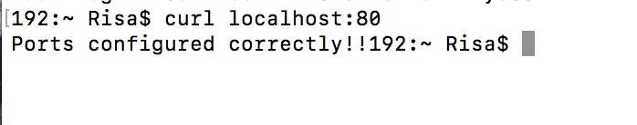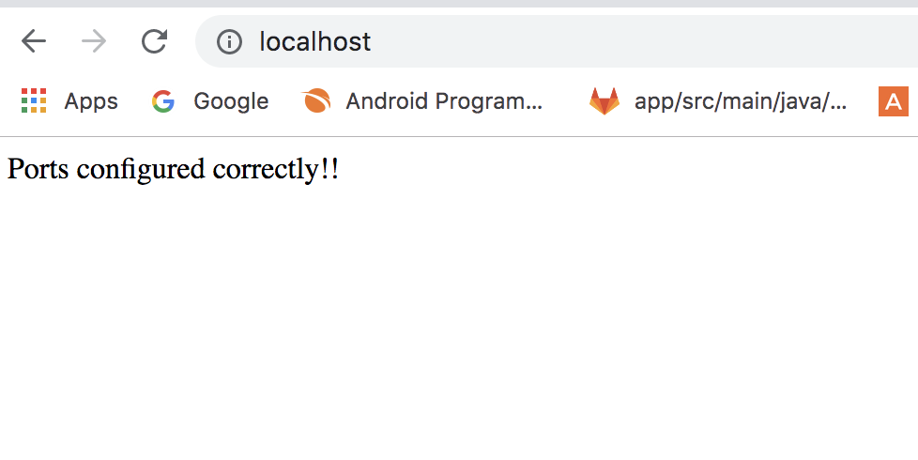then Open another terminal and run

#curl localhost:80

or open Web Browser and run localhost:80 to check the result